LAB MANUAL 1 TO 5 EXPERIMENTS

- Simple Calculator

AIM:

To perform basic arithmetic operations like addition, subtraction, multiplication, and division.
ALGORITHM:
- Start
- Read two numbers
- Read the operator.
- Perform the operation based on the operator.
- Display the result.
- Stop.

PROGRAM:

num1 = float(input("Enter first number: "))
num2 = float(input("Enter second number: "))

operator = input("Enter operator (+, -, *, /): ")

if operator == '+':
print("Result:", num1 + num2)
elif operator == '-':
print("Result:", num1 - num2)
elif operator == '*':
print("Result:", num1 * num2)
elif operator == '/':
if num2 != 0:
print("Result:", num1 / num2)
else:
print("Division by zero is not allowed")
else:
print("Invalid operator")

RESULT:

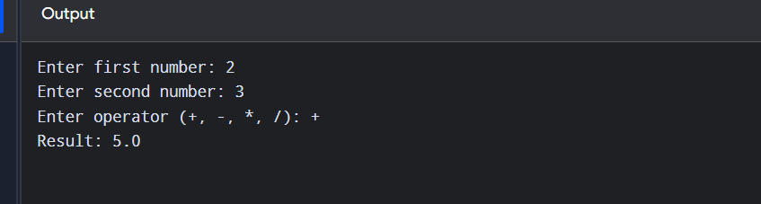

2. Add Two Matrices
Aim:
To add two matrices of the same size.
Algorithm:
- Start.
- Read the number of rows and columns.
- Read two matrices.
- Add corresponding elements of both matrices.
- Display the resultant matrix.
- Stop.
PROGRAM:
rows = int(input("Enter number of rows: "))
cols = int(input("Enter number of columns: "))
print("Enter elements of first matrix:")
matrix1 = []
for i in range(rows):
row = []
for j in range(cols):
row.append(int(input()))
matrix1.append(row)

print("Enter elements of second matrix:")
matrix2 = []
for i in range(rows):
row = []
for j in range(cols):
row.append(int(input()))
matrix2.append(row)

result = []
for i in range(rows):
row = []
for j in range(cols):
row.append(matrix1[i][j] + matrix2[i][j])
result.append(row)

print("Sum of matrices:")
for row in result:
print(row)

OUTPUT:

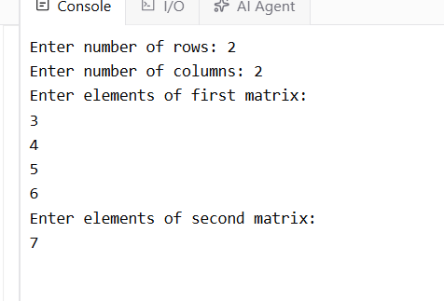

3.Transpose a Matrix
Aim:
To find the transpose of a matrix.
Algorithm:
- Start.
- Read the number of rows and columns.
- Read the matrix elements.
- Interchange rows and columns.
- Display the transpose matrix.
- Stop.
PROGRAM:
rows = int(input("Enter number of rows: "))
cols = int(input("Enter number of columns: "))

print("Enter matrix elements:")
matrix = []
for i in range(rows):
row = []
for j in range(cols):
row.append(int(input()))
matrix.append(row)

transpose = []
for i in range(cols):
row = []
for j in range(rows):
row.append(matrix[j][i])
transpose.append(row)

print("Transpose of matrix:")
for row in transpose:
print(row)

OUTPUT:
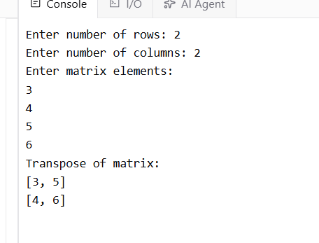

4. Sort Words in a Sentence Alphabetically
Aim:
To sort the words in a sentence in alphabetical order.
Algorithm:
- Start.
- Read a sentence.
- Split the sentence into words.
- Sort the words alphabetically.
- Display the sorted words.
- Stop.
PROGRAM:
sentence = input("Enter a sentence: ")

words = sentence.split()
words.sort()

print("Words in alphabetical order:")
for word in words:
print(word)

OUTPUT:
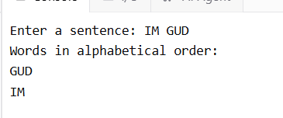

5.List Operations
Aim:
To implement basic list operations such as nested list, length, concatenation, membership, iteration, indexing, and slicing.
Algorithm:
- Start.
- Create lists.
- Demonstrate nested list.
- Find length of a list.
- Concatenate two lists.
- Check membership of an element.
- Iterate through list elements.
- Perform indexing and slicing.
- Display all results.
- Stop.
PROGRAM:
list1 = [10, 20, 30, 40, 50]
list2 = [60, 70, 80]

nested_list = [list1, list2]

print("Nested List:", nested_list)

print("Length of list1:", len(list1))

combined_list = list1 + list2
print("Concatenated List:", combined_list)

element = 30
if element in list1:
print(element, "is present in list1")
else:
print(element, "is not present in list1")

print("Iterating through list1:")
for item in list1:
print(item)

print("First element:", list1[0])
print("Last element:", list1[-1])

print("Slicing list1 from index 1 to 3:", list1[1:4])

OUTPUT:
